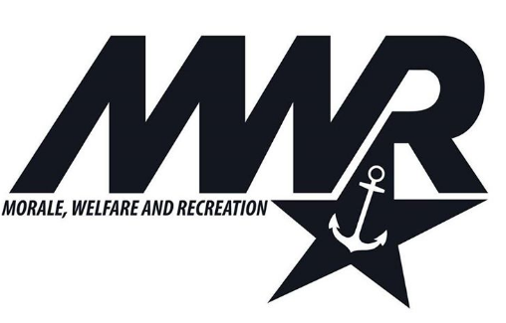

Skipper B/ASA101 Sailing Class
Mulberry Cove Marina
NAS Jacksonville

V7.0 10/2/22

First Saturday, Marina, 0800-1400
ON LAND:
Admin/paperwork and Introductions
Safety Review
PFD
Swimming Ability
Sailing Areas for Flying Scots
Whistles
1 - Attention or command
2 - Command
3 - Come to Me
5 - Danger
Parts/nomenclature Page 20
How Sailboats work Page 60
Sailing terminology
Points of sail Page 18, 48
Knots – Stopper Page 64
Parts of a Flying Scot (Video, then on Land)
Feel the Wind (Video, Questions, Exercise)

ON WATER:
Procedures for getting in and out of boats
Rigging a Flying Scot (Demo then Do)
Swim check
Capsize and recovery

Lunch break

ON LAND:
Review Points of Sail (Video, chalkboard, Exercise) Page 18, 48
Sailing Chair drill on-land (Video then Exercise)
Hand Signals
Luff Up, Sheet in, Sheet Out, Safety Position/Heave to
Stop and Go / Safety Position
Tacking / Sailing upwind Page 50
Knots – Round turn and 2 half hitches Page 64

SAILING: (Mainsail Only)
Tacking Beam to Beam, Close to Close(No Jibing)
Stop and Go, Safety Position
Mooring Ball and Docking (Instructor Demo)
De-Rig and Fold Sails
Knots – Square Page 64

First Sunday, Marina, 0800-1400
ON LAND:
Points of sail: Review Page 18, 48
Determining Wind speed and REEFING concept
(Reefing details in 103 class)
Adding the Jib Sail – Working with two sheets Page 45
Jib Halyard and Forestay tension
Jibing Theory – Page 52
Triangle, Circle, Slalom
Knots – Cleat Hitch Page 64

SAILING:
Tacking/Jibing, Stop/Go, Mooring/Dock
Apply Knots

Lunch break

ON LAND:
Rules of the road - “The Big 4”
Getting out of irons, Sculling Page 44
Landing on a dock Theory Page 83
Knots – Bowline Page 64

SAILING:
Landing on a dock / Getting out of Irons / Rules Applied
De-rig and secure the boats
Roll and stow sails

Second Saturday, Marina, 0800-1400
ON LAND:
Points of sail: Review Page 18, 48
Man overboard Theory Page 106
Knots – Clove hitch

SAILING:
Man Overboard Drills
Securing Sails on the boat

Lunch break

Man Overboard Drills
Fun Races, Follow the Leader,
Landing on a dock
De-rig and secure the boats
Roll and stow sails
Second Sunday, Marina, 0800-1400
ON LAND:
Knots Review- Cleat, Clove, Square, RTATHH, Bowline
How to call for help - Cell Phone, VHF, Whistle, Gesture, Sails
(VHF details in 103 class)

SAILING:
Man Overboard Drills
Fun Races, Follow the Leader,
Landing on a dock
De-rig, secure the boat
Roll and stow sails

Lunch break

ON LAND:
Birthplace of the Blue Angels
NAS Sailing Club
How to rent boats
Skipper B and ASA101
Test and Certifications

CLASS NOTES:

Instructors will determine when reefing is required and Instructors will reef the boats as needed. Reefing is a method of reducing sail in order to reduce a boat’s reaction to the wind thus giving the new sailor a gentler experience leading to improved learning.

Skipper B101 class is geared to developing Basic Sailing skills through instruction and practice. Skipper B103 class will cover more advanced topics including Reefing, VHF communication, Outboard motors, Navigation, Advanced Sailing techniques, etc.

Class times at 0800-1400. However, weather delays are sometimes issued by the NAS requiring students to leave the water. During such delays, the Instructor will determine the best course of action including:
Dismiss or Recess class
Continue Land-Based Instruction
Extend class upto but not beyond 1600

